ULTRASONIC THICKNESS MEASUREMENT REPORT
Company/Client: NCOC N.V. |  |  |  |  | Project: ESKENE WEST KARABATAN |  |  |  |  |  |  |  |  | Location: KUT 520
Line No/Tag No:  A1-5200-UW-141-6”-A21-WN |  |  |  |  | Component examined |  | Material |  |  |  | A333 Gr 6 SMLS |  |  | Probe sensitivity calibration
Procedure No:  GOST 28702-90  QP-11-UTT-Q01 Rev 01 |  |  |  |  |  |  | Diameter |  |  |  | 6”× 7.11 mm. |  |  | Probe S/N |  |  |  | 925366
 |  |  |  |  |  |  | Operating Temp |  |  |  | 35º C |  |  | Angle |  |  |  | 0º
Manufacturing Code/Acceptance Standard:  ASME B31.3 |  |  |  |  | Reference Calibration Block Details |  | Block |  |  |  | Step wedge  CS 1018 |  |  | Frequency |  |  |  | 5 MHz
 |  |  |  |  |  |  | Range |  |  |  | (6.25-25 mm) |  |  | size |  |  |  | 11 mm
Method: Contact |  |  |  |  |  |  | Accuracy |  |  |  | 0.025 mm |  |  | Crystal |  |  |  | Dual
Surface condition: not coated |  |  |  |  |  |  | Temperature |  |  |  | Ambient |  |  | Reference sensitivity |  |  |  | 2nd backwall reflection to 80% FSH
Couplant: Gel |  |  |  |  | Correction factors |  |  |  |  |  | N/A |  |  | Scan Sensitivity |  |  |  | +6 dB
S. No | Equipment/  Material Name |  | Manufacturer |  |  |  |  | Serial No |  |  |  | Calibration certificate No |  |  |  | Calibration Expiry date
 | A-scan UT |  | OLYMPUS DL-38 |  |  |  |  | 171421601 |  |  |  | A-01-0552 |  |  |  | 02-04-2019
 | Step wedge calibration block |  | OLYMPUS |  |  |  |  | 145414 |  |  |  | - |  |  |  | -
Job description:
UT Lamination check has performed 50 mm on the base metal of the 6” pipeline from both ends to ensure cut off position.

Legend: -

INSPECTION RESULTS
No |  | Item description |  |  |  | Nominal Thickness (mm) |  |  | Min (mm) |  |  |  | Max (mm) |  |  |  | UT-Lam Result
1 |  | Pipe |  |  |  | 7.11 |  |  | 6.00 |  |  |  | 8.25 |  |  |  | No lamination
2 |  | Pipe |  |  |  | 7.11 |  |  | 6.02 |  |  |  | 8.50 |  |  |  | No lamination
Examined by  UT L III cert. No. #282671  exp. date: 01.05.2021 |  |  |  | Name: Arul Vignesh |  |  |  |  |  | Signature:............................................ |  |  |  |  | Date: 30.07.2018
Approved by  UT L III cert. No. #282671  exp. date: 01.05.2021 |  |  |  | Name: Arul Vignesh |  |  |  |  |  | Signature:............................................ |  |  |  |  | Date: 30.07.2018
Client Representative: |  |  |  | Name:…………………………………… |  |  |  |  |  | Signature:............................................ |  |  |  |  | Date: …………………………

LOC-01
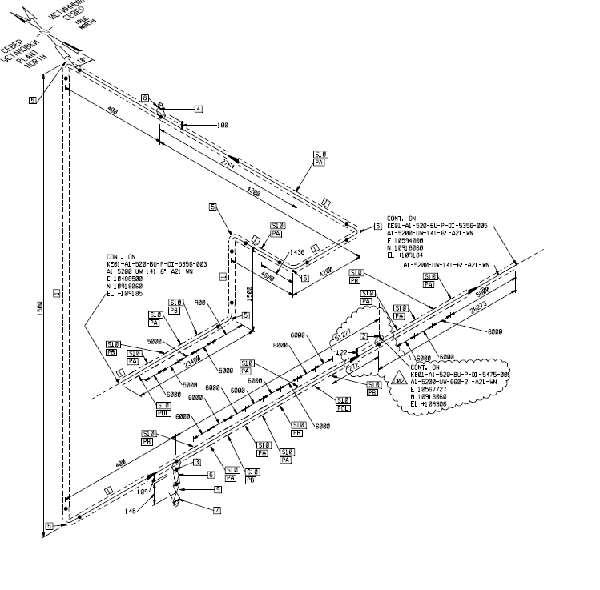
LOC-02
Cut off position 500 mm away
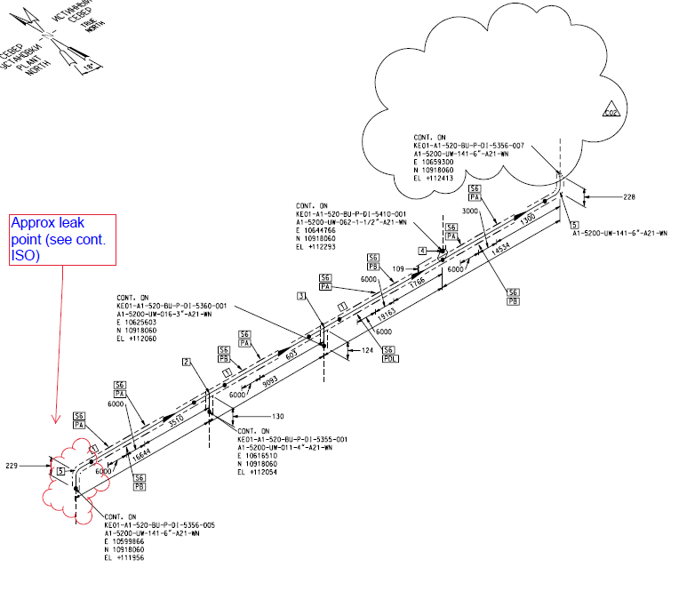
Cut off position 3 m away
Examined by  UT L III cert. No. #282671  exp. date: 01.05.2021 | Name: Arul Vignesh | Signature:............................................ | Date: 30.07.2018
Approved by  UT L III cert. No. #282671  exp. date: 01.05.2021 | Name: Arul Vignesh | Signature:............................................ | Date: 30.07.2018
Client Representative: | Name:…………………………………… | Signature:............................................ | Date: …………………………

